## Login Screen

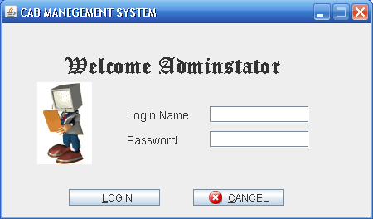

[29]

## Login Failed

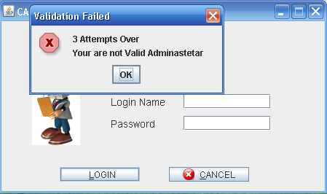

[30]

**Main Screen**

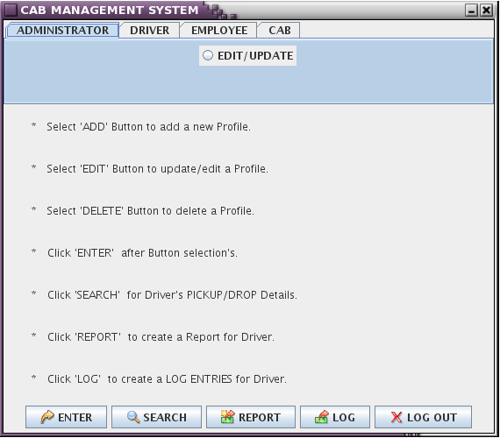

**This is next screen after successful Login**

[31]

**Adding Driver Entry into Database**

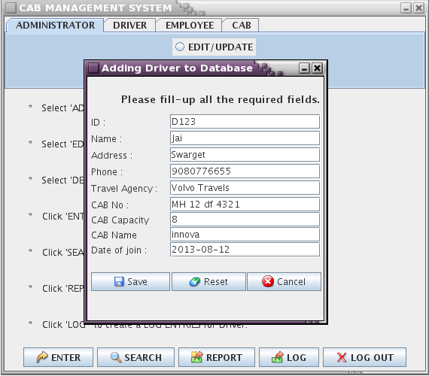

[32]

**Delete Driver From List**

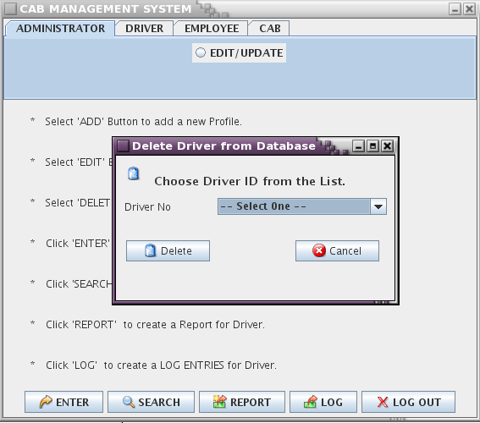

[33]

**Adding Employee Entry To Database**

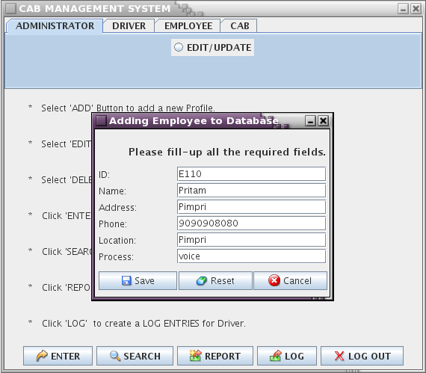

[34]

**Adding Cab Entry To Database**

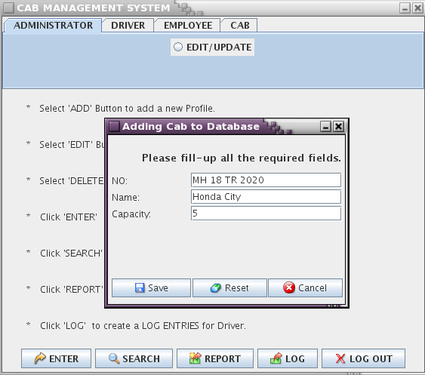

[35]

**Searching**

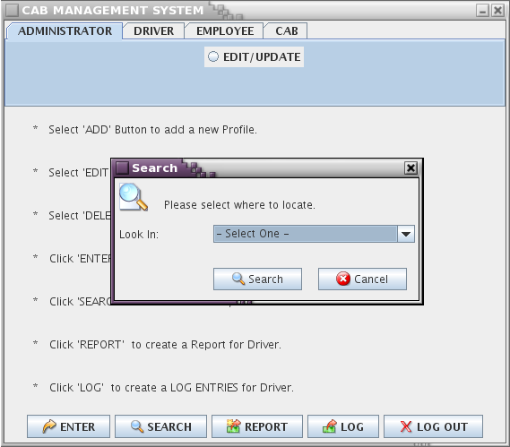

[36]

**Search Entry For Working Driver**

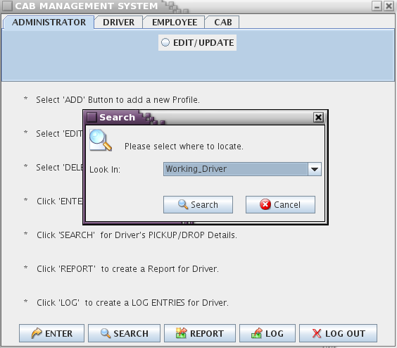

[37]

**Search Entry For Non-Working Driver**

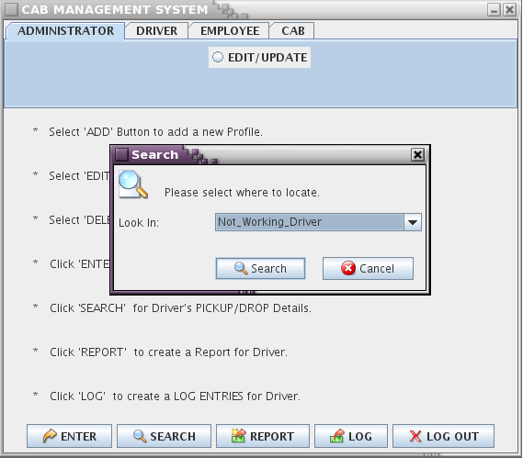

[38]

**Search Entry For Cab**

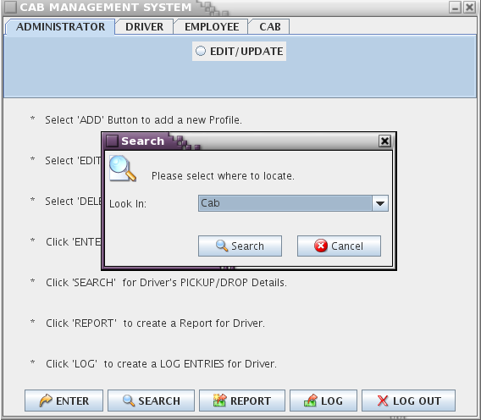

[39]

**Search Entry For Log Register**

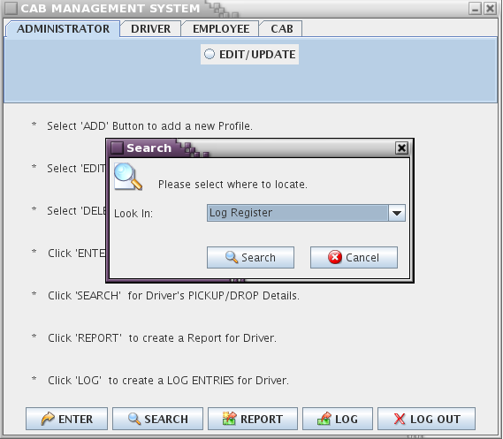

[40]

**Search Entry For Employee**

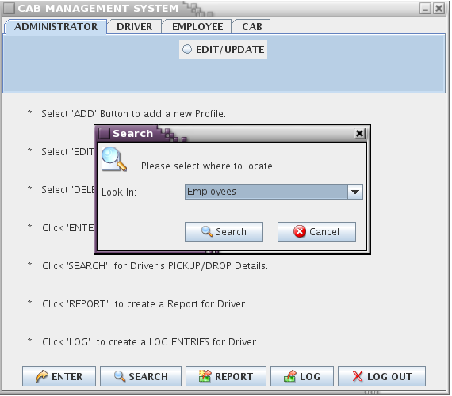

[41]

**Adding Entry Of Driver To Log Register**

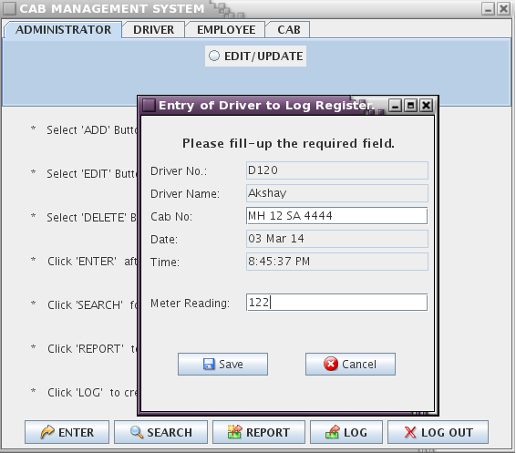

[42]

**Driver Entry To Database**

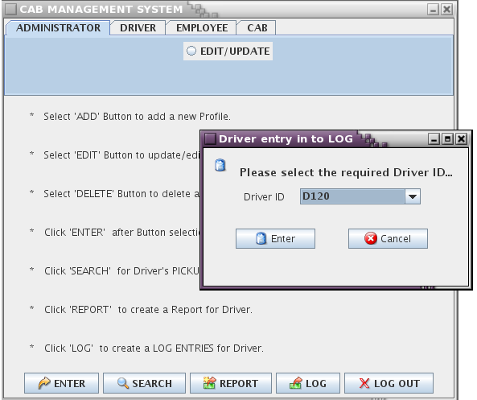

[43]

**Validation Of Driver**

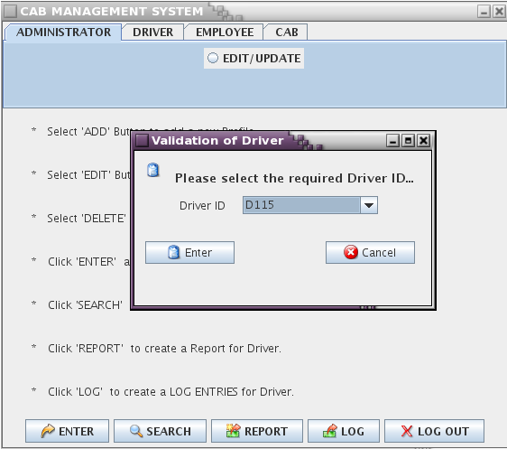

[44]

***Report For Driver***

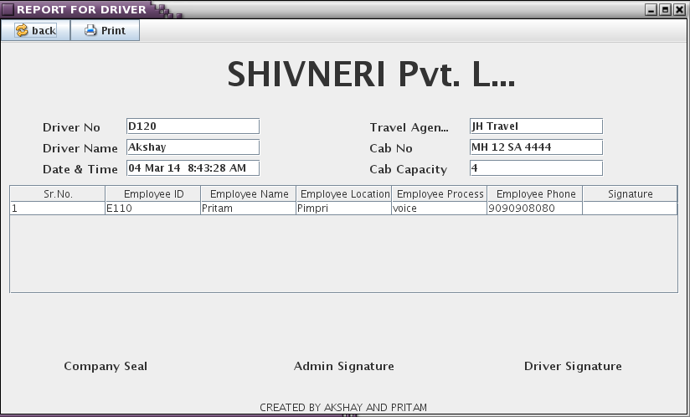

[45]